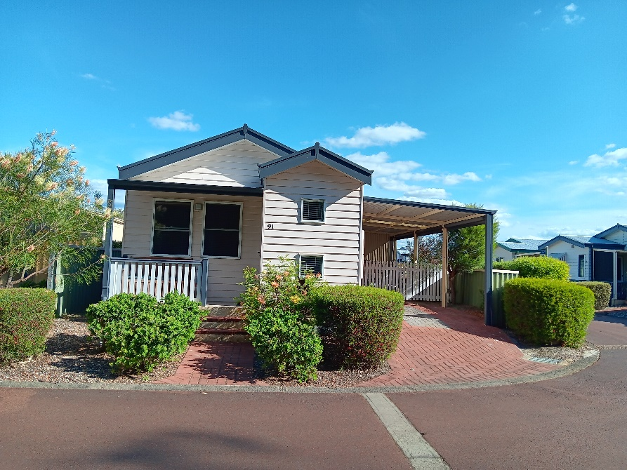

**Beautiful home an opportunity not to be missed!**

**1 Bed, 1 Bath, 1 WC, 1 Car**

* Great location on corner block.
* Built in cabinetry and study nook.
* Spacious Kitchen with Electric oven, gas hot plate and microwave recess.
* Open plan Living
* Reverse cycle air-conditioning in lounge/dining area.
* Bedroom with large, mirrored wardrobe space and ensuite bathroom.
* Great back patio area with quality blinds for extra privacy.
* Lock up shed.
* External access to laundry room.
* A short stroll to Clubhouse, Tennis Court, Indoor Heated Pool, Gym, Bowling Green and so much more!

**This lovely home won’t last long!**

**Call today to arrange a viewing.**

Sussex

$250,000

as displayed

BSN091

ESTABLISHED HOME FOR SALE

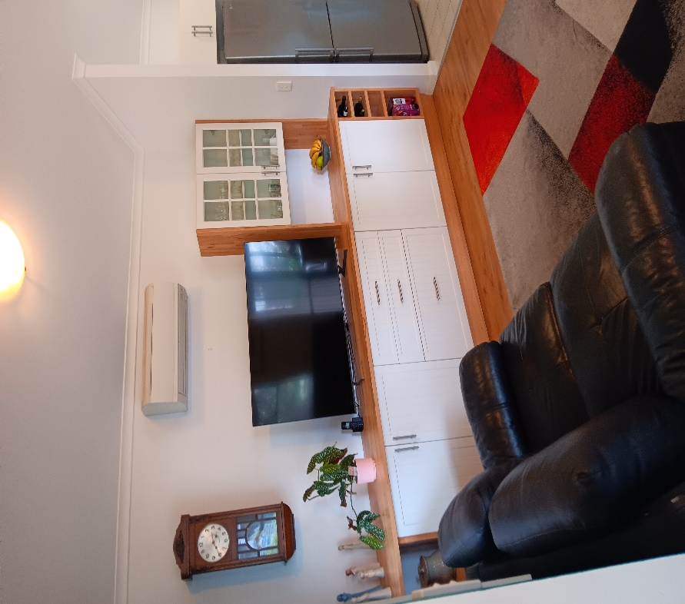

**Sales Enquiries Call: Amy 0417 124 800 or Chelsea 08 9752 6700**

**Email:** [**busselton@nlv.com.au**](mailto:busselton@nlv.com.au) **Website:** **nlv.com.au/busselton**